
January 2008 Volume II, No. 1
Among Friends

Tell a man there are 300 billion stars  in the universe and  he'll believe you.  Tell him a bench has WET PAINT  on it and he'll have to touch it to be sure.  Murphy's Law | For example, plenty of people in Squirrel Hill are still reading and bringing their children up to read. Did you know that our children's section has more visitors than that of any other library in the Pittsburgh Carnegie system, including the main library in Oakland? Amazing, yes, and only one of the things we have to be proud of. The Friends are happy to be earning record amounts through our book sales, so we can supplement the budget the Children's librarians have to purchase materials they need for the swarm of young readers.  We are also proud that Squirrel Hill residents think first of the Friends when they want to honor or remember someone – donating either money or unusual books. One such person is donating his entire collection of old-time sheet music – a fabulous collection that will line our coffers I'm sure. We are planning a special event this summer showcasing this exciting donation. We’re seeking a keyboarder who’d like to participate. Call 421-521-4129.  One of the signs that the library is working toward a better future is the large number of computers we provide, free of charge – and the wide assortment of folks of all ages who take advantage of them. The Friends will be making it more comfortable to work at the computer stations by purchasing new chairs that can be adjusted to any height at the touch of a button. We hope they will arrive in time for us to be able to brag about them in our next newsletter!  Yes, it's been a good year for the FOL – and I'm hoping 2008 will be even better. I'm wishing that for all of our members and for the many other users of our library who just haven't joined us yet. Ho! Ho! Ho!
  
  WELCOME,
  NEW MEMBERS
  Corrine Barbato
  Gina Boyd
  Mary Bullock
  Jane DeYoung
  Dawn Garand
  Warren Garrison
  Mimi Gillis
  Albert Weiner & Carol Gluck
  Theresa Haas
  Tony Iannuzzi
  Drynda Johnston
  Barbara E. Katz
  Paul Klein
  Kimberly Koenig
  Daniel Kovalik
  Richard Lees
  Daniel Leya-Warnock
  William Marcellino
  Kalin Morrow
  Wanda Nichols
  R Ravi
  Paul Schaeffer
  Ray & Mary Schinhofen
  Nick Schorr
  Leann Sherman
  M. Ellen Smith
  PRESIDENT’S MESSAGE  Marion Damick  Another year is over; another year has begun. As we reflect on the state of our world, all around us are signs of recession (store sales), war (Iraq), and poverty (record crowds at the food banks). But there are signs of hope. In our own small way, the Friends of the Squirrel Hill Library are doing very well. | 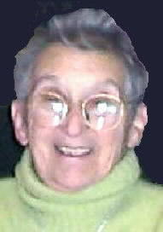
  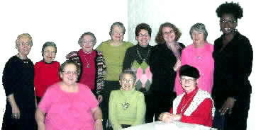  From Left: Pat Bender, Anita Newell, Esther Tucker, Joan Schwartzman, Ina Sable, Holly McCullough, Marilyn Honigsberg, Kim Morrison  Seated: Margie Spenser, Marion Damick, Shirley Streff | Join us at our  Friends  Meetings:  Saturdays  at 10 a.m:  January 5  February 2  March 1  April 5

Published by the Friends of the Squirrel Hill Library
5801 Forbes Avenue Pittsburgh, PA 15217
website: www.clpgh.org/locations/squirrelhill e-mail: Friends@pittsburghusedbooks.com
editing: Joan Schwartzman production: Margie Spenser, Marion Damick, Serena Spenser mailing list: Bob Gundersen

January 2008 Among Friends Volume II, No. 1

  Art at the  Squirrel Hill Library  Coming up are:  January: Katerina Kitchen  Photos  February: Maureen Hahn  Watercolors  March: Margaret Caine  Watercolors  If you are interested in exhibiting, or know of someone who is, contact Marion Damick, 412-521-3075. | The Squirrel Hill Children’s department would like to thank the Friends for their generous support during this past year. With their help, we were able to provide wonderful programs, books, and equipment for children and families using the library. We look forward to working with the Friends in the New Year.  Here are just a few of the great reasons to keep coming to the library all winter long — great programs for kids and families:  Wacky Wednesdays: School Age Fun  Kids ages six and up join us at 4:30 p.m. every Wednesday. The first Wednesday of the month features fun stories and a cool craft. Science Fun happens on the second Wednesday. On the third Wednesday hear an art-related story and try your hand at a related art project during Artful Stories. Play a fun game of book bingo and win a prize on the fourth Wednesday.  KinderPrep  KinderPrep is a literacy-based program designed to reinforce skills for children entering Kindergarten in fall 2008. This program will be held on the third Tuesday evening of every month from October through May at 6:00 p.m. Stop by the Children’s Room for more information and to register!  Origami  The Origami Club of Pittsburgh holds beginning origami classes at the library on the third Saturday of every month at 12:00 p.m. An advanced folding class is held at 1:30 p.m. Come join the fold!  Family Storytime  Families join us for stories, songs, and rhymes every Saturday at 11:00 a.m. and every Monday at 6:00 p.m.  Toddler Storytime  Toddlers and parents, come and listen to stories, plus try rhymes and songs together. Recommended for ages 18 months to three years. Tuesdays at 10:30 a.m. and repeats at 11:30 a.m.  Baby Lapsit  For a fun and playful experience, babies and caregivers will participate in fingerplays, rhymes and songs. Recommended for babies up to 18 months. Thursdays at 10:30 a.m. and 11:30 a.m.  Check out our website for more fun programs:  http://www.carnegielibrary.org/ kids/happening/
  Children’s Room Happenings | by Erin Scioli  Children's Library  Assistant | 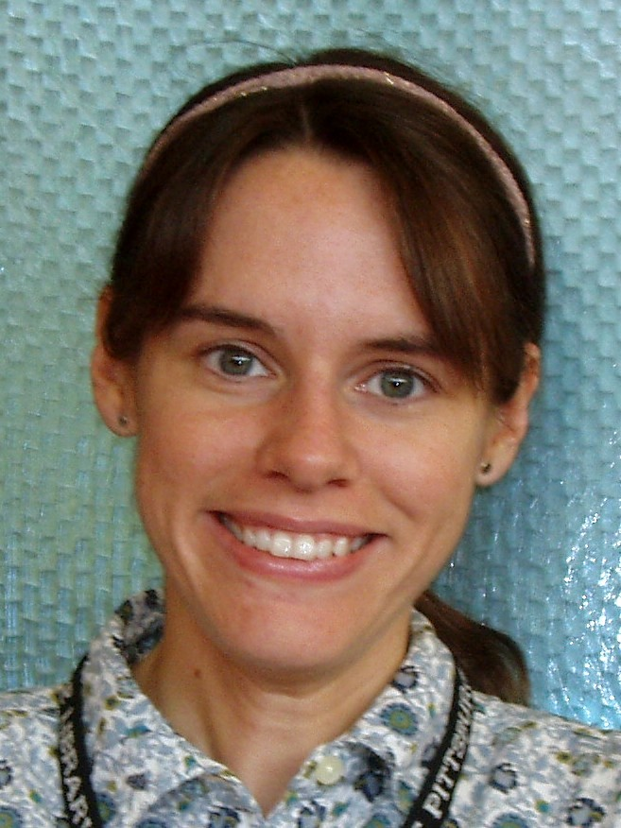
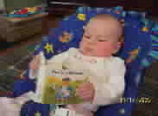
TV
if kids are entertained by two letters, imagine the fun they’ll have with twenty-six.
Open your child’s imagination. Open a book.

Author Unknown
2

January 2008 Among Friends Volume II, No. 1



WANTED: VOLUNTEERS

WHERE: SQUIRREL HILL LIBRARY

WHEN: WHENEVER YOU HAVE THE TIME

CONTACT: AUDREY HINES, Senior Librarian
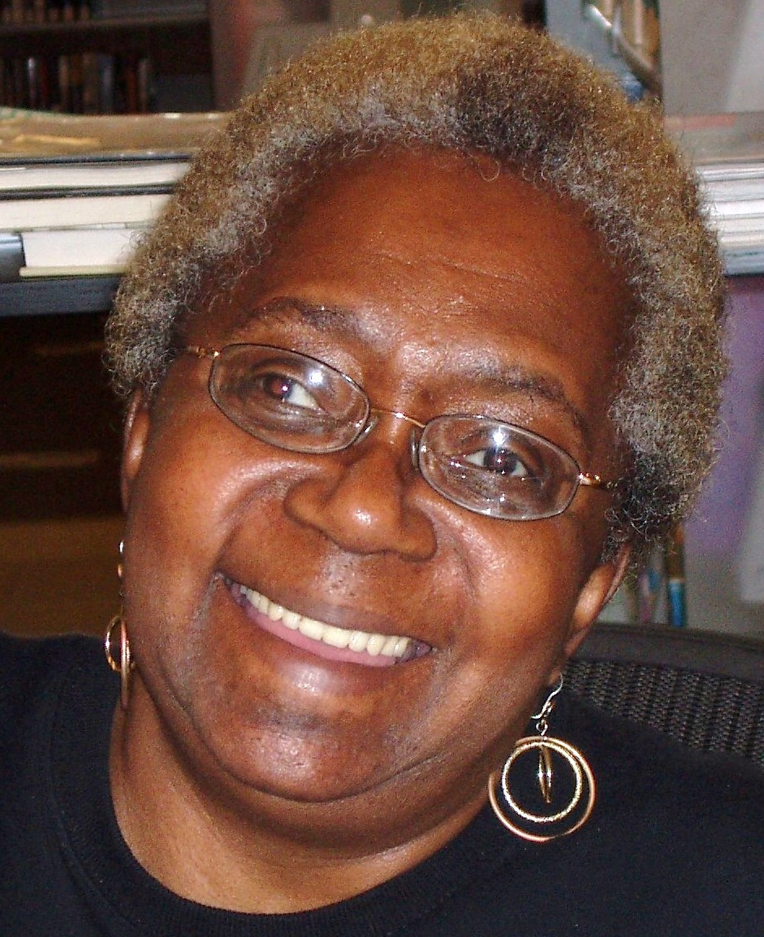
Telephone 412-422-9650 or go online to
http://www.carnegielibrary.org/support/volunteer/

 | Film, Fiction and Fun  The Film, Fiction, and Fun program series continues to explore the relationship between classic novels and the films they inspired. Meetings are held on the last Thursday of each month.
January 31st 1-4 PM The Great Gatsby by F. Scott Fitzgerald  February 28th 1-4 PM Lolita by Vladimir Nabokov  March 27th 1-4 PM Wuthering Heights by Emily Bronte  Participants are encouraged to read the novel, then join us for a screening of the film and a discussion led by CCAC's Jeanne Bergad. | 

Reading is to the mind what exercise is to the body.
It is wholesome and bracing for the mind to have its faculties kept on the stretch.
Augustus Hare
1834-1903
3

January 2008 Among Friends Volume II, No. 1

MINI SALE NEWS  January's mini sale will concentrate on audio-visual materials. We have videos and DVDs for adults and children, books on tape and CD, music tapes and CDs galore, and even some LPs. We also have books about composers and performers. Sale dates are January 19-20 during library hours.  February is Black History month. Our mini will celebrate it with a sale of books on black history, life and art. There will be fiction and nonfiction for adults, teens and children. Mark your February calendar for the 19th and 20th.  Your donations are the basis of our success and so we continue to ask for books, tapes, |  |  | 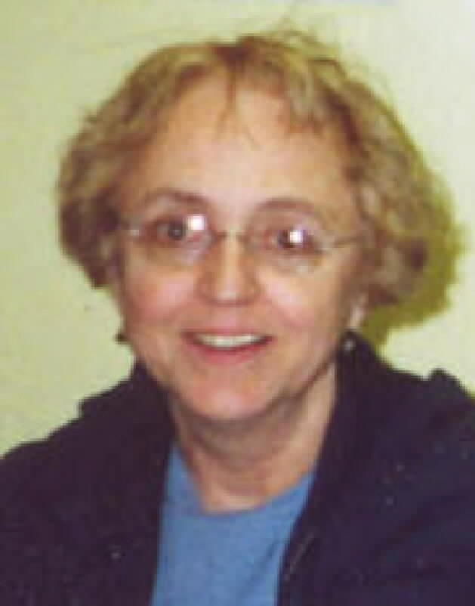  by Pat Bender, mini-sale chair
and disks in good condition. Leave them at the service desk or outside the Friends workroom any time. A staff member can give you a receipt for tax purposes.

We will also continue our sale of "Friends" book jewelry etc. with many new items, some in anticipation of Valentine's Day. I am on the lookout for donations of broken or discarded jewelry items - beads, chains, single earrings or any small object that would help this project. These donations may also be left at the desk for a receipt. Thanks!

A heartfelt "thank you" to each of you for your support of the Friends' mini sales. Each one seems to do better than the one before. Our September Judaica sale earned $400 compared to last year's $125. The November sale brought in $2,225, doubling last year's total.

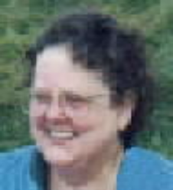  by Margie Spenser  Book Sale Committee | BOOKS, BOOKS, BOOKS, BOOKS, BOOKS, BOOKS, BOOKS, BOOKS………  It's been a busy year. I've been having some major work done on my house, so Pat Bender, Shirley Streff, and Sam Blackburn have had much less help from me than usual. They have been fantastic. Thanks, guys!  To Friends who want to help sort books: we need you and you are welcome anytime. If you see that our workroom door is open, stop in and talk about how you can help. You're most likely to find somebody there in the afternoons between 1 and 3. You can
also e-mail us at friends@pittsburghusedbooks.com, or call Shirley (412-371-4114) or Pat (412-422-3728) to set up a time to meet and see what is involved.

Our Fall Used Book Sale just before Halloween was great. We added $2,607.22 to the treasury, and we found a young bookseller who came from Ohio to buy all our remainders. He tells us that he found a few gems and a lot of semi-precious books, and we not only made money ourselves, but he packed up everything almost entirely without our help! I hope this is the beginning of a long and beautiful partnership.

We had so many like-new and special books for the November Holiday Shopping mini sale that we continued to display them through the end of 2007. We have no way to know how much of the ongoing sale money in December came from these books, but I believe the total for the sale would be much higher than Pat reported, if there were a special key on the cash register for income from our special sales.

Pat's too modest to mention it, but her Friends "book jewelry" almost sold out at the November sale. At only $5 per item, it brought in more than $100. There was some talk of displaying items for sale
on the kiosk next to the service desk, but because of security concerns your only opportunity to buy these handcrafted pieces will be at our used book sales. Come check it out!  Many persons read and like fiction. It does not tax the intelligence,  and the intelligence of most of us  can so ill afford taxation  that we rightly welcome  any reading matter  which avoids this.  Rose Macaulay  1881-1958  We have begun to plan the used book sales for 2008; see page 8. Flyers for the first two sales are provided; flyers for the March and April sales will be available at the beginning of their respective months at the Customer Service desk.  4 |  | 4

January 2008 Among Friends Volume II, No. 1
 | All programs are scheduled for Wednesday  from 10:15 AM-11:00 AM  January 16  Franchising: Learn how to find the right franchise for you.  By John Tubridy, President, FranNet  January 23  Key tips for caring for an aging parent.  Learn about help and services available in the area.  By Andrea Seewald, President, The Care Registry Inc.  February 20  Constructive living: practical strategies for  taking charge of the quality of your life.  By Neal Griebling, President, Future Design Studio Inc.  February 27  Key databases for your business plan.  By Dorothy Kabakeris, Librarian,  Carnegie Library of Pittsburgh – Squirrel Hill  March 19  Trust and wills: Learn the major differences.  By Eric Blazer, PNC Financial Services  March 26  Simple Steps to Take the Work Out of Networking  By Bonnie Budzowski, President, InCredible Messages, LP.
  NAMM BUSINESS CENTER PROGRAMS  January - March 2008  by Dorothy Kabakeris,  Namm Business Center Librarian | 
  INCOME TAX ASSISTANCE
  Once again we will offer free tax service for the public on Tuesdays (12-4), Thursdays (12-4) and Saturdays (10-4).
  The service is provided by IRS-trained AARP volunteers.
  We haven’t been notified about the official beginning date, but we expect the service will start late January or early February and will last until April 15th.
  The librarians will take all registrations by phone or walk-in.
  We will also have federal, state and city tax forms.
The Squirrel Hill
Adult Book Discussion Group
meets on the last Thursday
of the month from
1:00 PM to 2:00 PM.

All are Welcome.

January 24th
Manhunt: the Twelve-day Chase
For Lincoln’s Killer
by
James L. Swanson, 2006

February 28th
Beautiful Jim Key:
The Lost History of a Horse
And a Man
Who Changed the World
by
Mim Eichler Rivas, 2005

March 27th
Let Me Finish
by
Roger Angell, 2006

To acquire
the habit of reading
is to construct for yourself
a refuge from almost all
the miseries of life
W. Somerset Maugham
1874-1965
.
For lots of other NAMM news, sign up to receive the newsletter at: squirrelhill@ carnegielibrary.org
5

January 2008 Among Friends Volume II, No. 1

I am waiting for you to write back to me. People keep telling us how great the new format is, but we can't copy a sound track on our printer.  You don't have to restrict yourself to praise, although we love it. We'd like any kind of feedback. Comments, complaints, suggestions, questions – are you there? Hello??  Write us at FOL, Squirrel Hill Library, 5801 Forbes Ave, 15217 or e-mail us at friends @ pittsburghusedbooks.com.  Computers are useless. They can only tell you  the answers.  Pablo Picasso  1891-1973  Carnegie Library of Pittsburgh -  Squirrel Hill Library:  - Had over 450,000 visitors in 2007!  - Has wireless internet access throughout the building!  - Circulated over 400,000 items in 2007!  - Had over 20,000 people attend our programs!  Editor's note: and our library continues to provide amazing amounts of information and support to many community groups and interests. For example, see the box at right. | Friends' Corner    In recognition of the 60th birthday of Israel and in partnership with the United Jewish Federation of Pittsburgh, the Carnegie Library of Pittsburgh – Squirrel Hill location will be highlighting Israeli literature with a special book display and book list throughout the month of March. Reunite with some favorites or explore unfamiliar titles and authors. This is just one event that will be happening in the community throughout the year to commemorate Israel@60. For a list of more events check out the UJF’s website: http://www.ujf.net/  ________________________________  Did you know that, as part of the library’s service to the community, hundreds of organizations held a program or meeting in one of our meeting rooms last year? Wondering how you can utilize one of the spaces at the library for your group?  Contact Librarian Audrey Hines for more information @ 412-422-9650.
  From the Editor  by Joan Schwartzman | 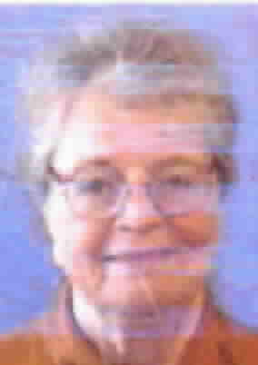
  Squirrel Hill Library  Quick Stats  by Holly McCullough,  Library Manager | 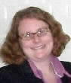
  MY SPAM DETECTOR  My spam detector gamely tries  To regulate my e-mail;  But cannot tell the truth from lies,  And doesn’t know I’m female.  They send ads aimed at body parts  Not relevant to me;  They offer rendezvous with girls –  Just not my cup of tea.  Communiques they often send  From rich Nigerian ladies  Who’ll share their wealth with me, their friend -  I wish them all in Hades! |   But oh, how vigilant they are  With e-mail from a friend;  And frequently my daughter’s notes  Will in the “junk” pile end.  But why should this my mind appall?  Why should I find it rum?  It’s a computer, after all –  No wonder it’s so dumb!
   | Esther Jacobson Tucker could probably use a break from filling our Friends' Corner all by herself. Please send your original work to the one of the addresses in the Editor's column. | 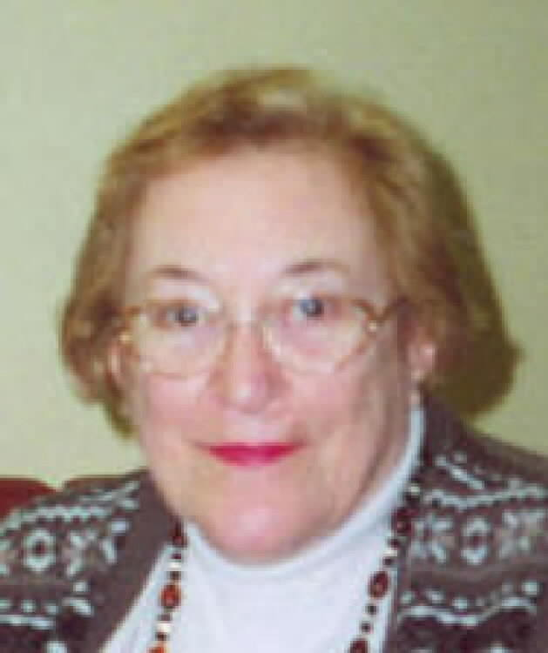

6

January 2008 Among Friends Volume II, No. 1

Friends Officers  Marion Damick President  Joan Schwartzman Vice President  Eleanor Hershberg Treasurer  Margie Spenser Secretary  write us at  friends@pittsburghusedbooks.com | BLACK HISTORY MONTH  BOOK SALE  black history, life, and art  fiction and nonfiction for adults, teens and children  Sat Feb 16th 10 a.m. to 4:30 p.m.  Sun Feb 17th 1 p.m. to 4:30 p.m.
  
  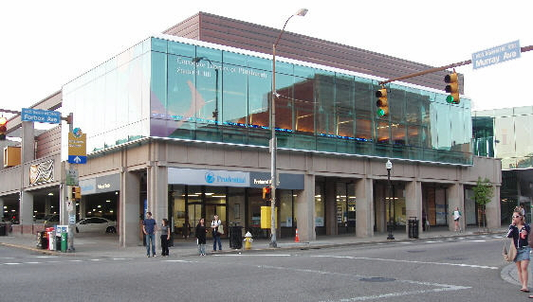  Squirrel Hill Library  5801 Forbes 412-422-9650 | DONATIONS WANTED
ROUGH DRAFT
watch for updates:

2008 Friends Book Sales

january – audio/video
february – Black History
march – to be announced
april – Spring Cleanup sale
during National Library Week
june – no sale
july – fiction, foreign language
during Squirrel Hill Sidewalk Sale
august – no sale
september – religion/philosophy/
Judaica

october – Fall Sale
november -- Holiday Shopping
Mini-Sale
december – no sale

for sales elsewhere, go to www.pittsburghusedbooks.com
Cut along the lines on the back for a reversible flyer.
If you can post a full-sized flyer at work, at school, etc., pick one up at the service desk at the library. They're available starting three weeks before the sale.
It's the Year of the Rat Potato

This is the Chinese year of the Rat, but the U.N. has declared it the Year of the Potato. January 3rd is National Chocolate Covered Cherry Day. Islamic holy days are based on the lunar calendar, and some events, such as fasting on Ramadan, may not begin when expected if the moon is not visible. How do I know these things??

I needed to check the dates for the Friends Meetings, which led to my reexamining the 2008 calendar I am building for my website, www.pittsburghusedbooks.com, which led to my checking online for the dates of some of the holidays. I found a really great website. It contains very complete lists of national and religious holidays, birthdays of famous persons, and zany commemorative "days". It's full of droll stuff: recipes, birth certificates for your teddy bear, animations and cartoons, and lessons in ventriloquism. There are explanations of Ramadan, the phases of the moon, how to wear a turban . . . .

Check out www.brownielocks.com for a whole lot more! ---Margie Spenser

The Friends of the Squirrel Hill Library
5801 Forbes Ave. Pittsburgh, PA 15217
www.clpgh.org/locations/squirrelhill
Friends@ pittsburghusedbooks.com
Library – 412-422-9650
open M-W 10-7, Th-S 10-5, Sun 1-5
"Free to the People"

CHILDREN'S WEEKLY EVENTS

Family Storytime-
all ages-
Monday at 6 PM and Saturday at 11 AM

Toddler Storytime-
18 months to 3 years-
Tuesday at 10:30 AM- repeated at 11:30 AM

Baby Lap Sit-
0 to 18 months-
Thursday- 10:30 AM to 11:30 AM

Wacky Wednesday-
school age-
4 PM
Library Facts…
The first Andrew Carnegie free library was founded in the town of his birth, Dunfermline, Scotland, on July 27, 1881. His first American library was built in Carnegie, Pennsylvania in May, 1901, at a cost of $93,000
Joseph Frazier Wall, in his biography of Carnegie, asserts that Carnegie built 2,811 free libraries in all. Of these, 1,946 were located in the United States – at least one in every state except Rhode Island -- 660 in Britain and Ireland, 156 in Canada. A handful of libraries (49) were also scattered in places like New Zealand, the West Indies and even Fiji.
Carnegie offered interested towns enough cash to build the library, usually about $2 per resident. In return, the town had to agree to shell out an amount equal to 10 percent of that gift each year for upkeep, utilities and books.
(adapted from Chris Potter,
Pittsburgh City Newspaper)

CHILDREN'S WEEKLY EVENTS

Family Storytime-
all ages-
Monday at 6 PM and Saturday at 11 AM

Toddler Storytime-
18 months to 3 years-
Tuesday at 10:30 AM- repeated at 11:30 AM

Baby Lap Sit-
0 to 18 months-
Thursday- 10:30 AM to 11:30 AM

Wacky Wednesday-
school age-
4 PM
Library Facts…
The first Andrew Carnegie free library was founded in the town of his birth, Dunfermline, Scotland, on July 27, 1881. His first American library was built in Carnegie, Pennsylvania in May, 1901, at a cost of $93,000
Joseph Frazier Wall, in his biography of Carnegie, asserts that Carnegie built 2,811 free libraries in all. Of these, 1,946 were located in the United States – at least one in every state except Rhode Island -- 660 in Britain and Ireland, 156 in Canada. A handful of libraries (49) were also scattered in places like New Zealand, the West Indies and even Fiji.
Carnegie offered interested towns enough cash to build the library, usually about $2 per resident. In return, the town had to agree to shell out an amount equal to 10 percent of that gift each year for upkeep, utilities and books.
(adapted from Chris Potter,
Pittsburgh City Newspaper)

If you have never said "Excuse me"
to a parking meter
or bashed your shins on a fireplug, you are probably wasting too much valuable reading time.

Sherri Chasin Calvo

The richest person in the world
-- in fact all the riches in the world -- couldn't provide you with anything like the
endless, incredible loot
available at your local library.

Malcolm Forbes
1919-1990

7

January 2008 Among Friends Volume II, No. 1
AUDIO/VIDEO  SALE  videos and DVDs for adults and children,  books on tape and CD, music tapes and CDs galore, and even some LPs  Sat Jan 19th 10 a.m. to 4:30 p.m.  Sun Jan 20th 1 p.m. to 4:30 p.m. | Make checks payable to:  Friends of the Squirrel Hill Library  and bring to the library or mail to:  Bob Gundersen  518 Guyasuta Rd.  Pittsburgh, PA 15215  Check one box:  New Member Renewal  Check one box:  $3.00 $5.00 DONOR (free)  $10.00 $25.00 Other _____  Name:___________________________________  ^{(Last)} (First) (Initial)  Address: _________________________________  City/State: __________________Zip: __________  Phone(s): ___________________Date: _________  E-mail address: ____________________________  Please check all activities you can help with:  Periodic Book Sales Sorting Used Books  Adopt-a-Shelf Program Gardening  Library Advocacy Newsletter/ Mailings  (lobbying, writing letters)  COMMENTS_________________________  _________________________________  _________________________________  _________________________________
  DONATIONS WELCOME
  Squirrel Hill Library
  5800 Forbes 412-422-9650
  5800 Forbes 41212-422-9650

Is your Friends Membership up to date? Please check your mailing label/membership card, below. If the date is before 01/08, you need to renew. If you bring this page to one of our Used Book Sales, you'll get a free book with your renewal. Or mail us the form above.
your donation is tax deductible as a charitable contribution
CARNEGIE LIBRARY OF PITTSBURGH  SQUIRREL HILL  5801 Forbes Avenue  Pittsburgh, PA 15217 |  | NON-PROFIT ORG.  U.S. POSTAGE  PAID  Pittsburgh, PA  PERMIT No. 307
Adult Services: 412-422-9650  Children's Services: 412-422-9841  Fax: 412-422-5811  www.carnegielibrary.org/clp/sq  You may wish to cut out the  mailing address box and use it  as a membership card. | ADDRESS SERVICE REQUESTED  8
  
  Expires:  Month YYYY | NAME  ADDRESS  CITY, STATE, ZIP

